Greenhouse study trip to Holland

If there is sufficient interest HortiServices plans to organize a study trip to the Dutch Greenhouse Horticulture. The Dutch greenhouse horticulture is very innovative and the knowledge is second to none. There are many challenges regarding energy saving, crop protection, labour availability and labour costs. This increases the cost price. At the same time, competition from abroad is increasing. How do Dutch growers manage to keep their heads above water again and again?

The main purpose of the trip is to visit greenhouse vegetable companies and companies that are related to this. Themes are filled in depending on the wishes of the participants and can cover, for example, varieties, biological crop control, lighting, automation and robotization, hygiene, substrates and research. Of course, time will also be set aside for enjoying the Dutch culture too.

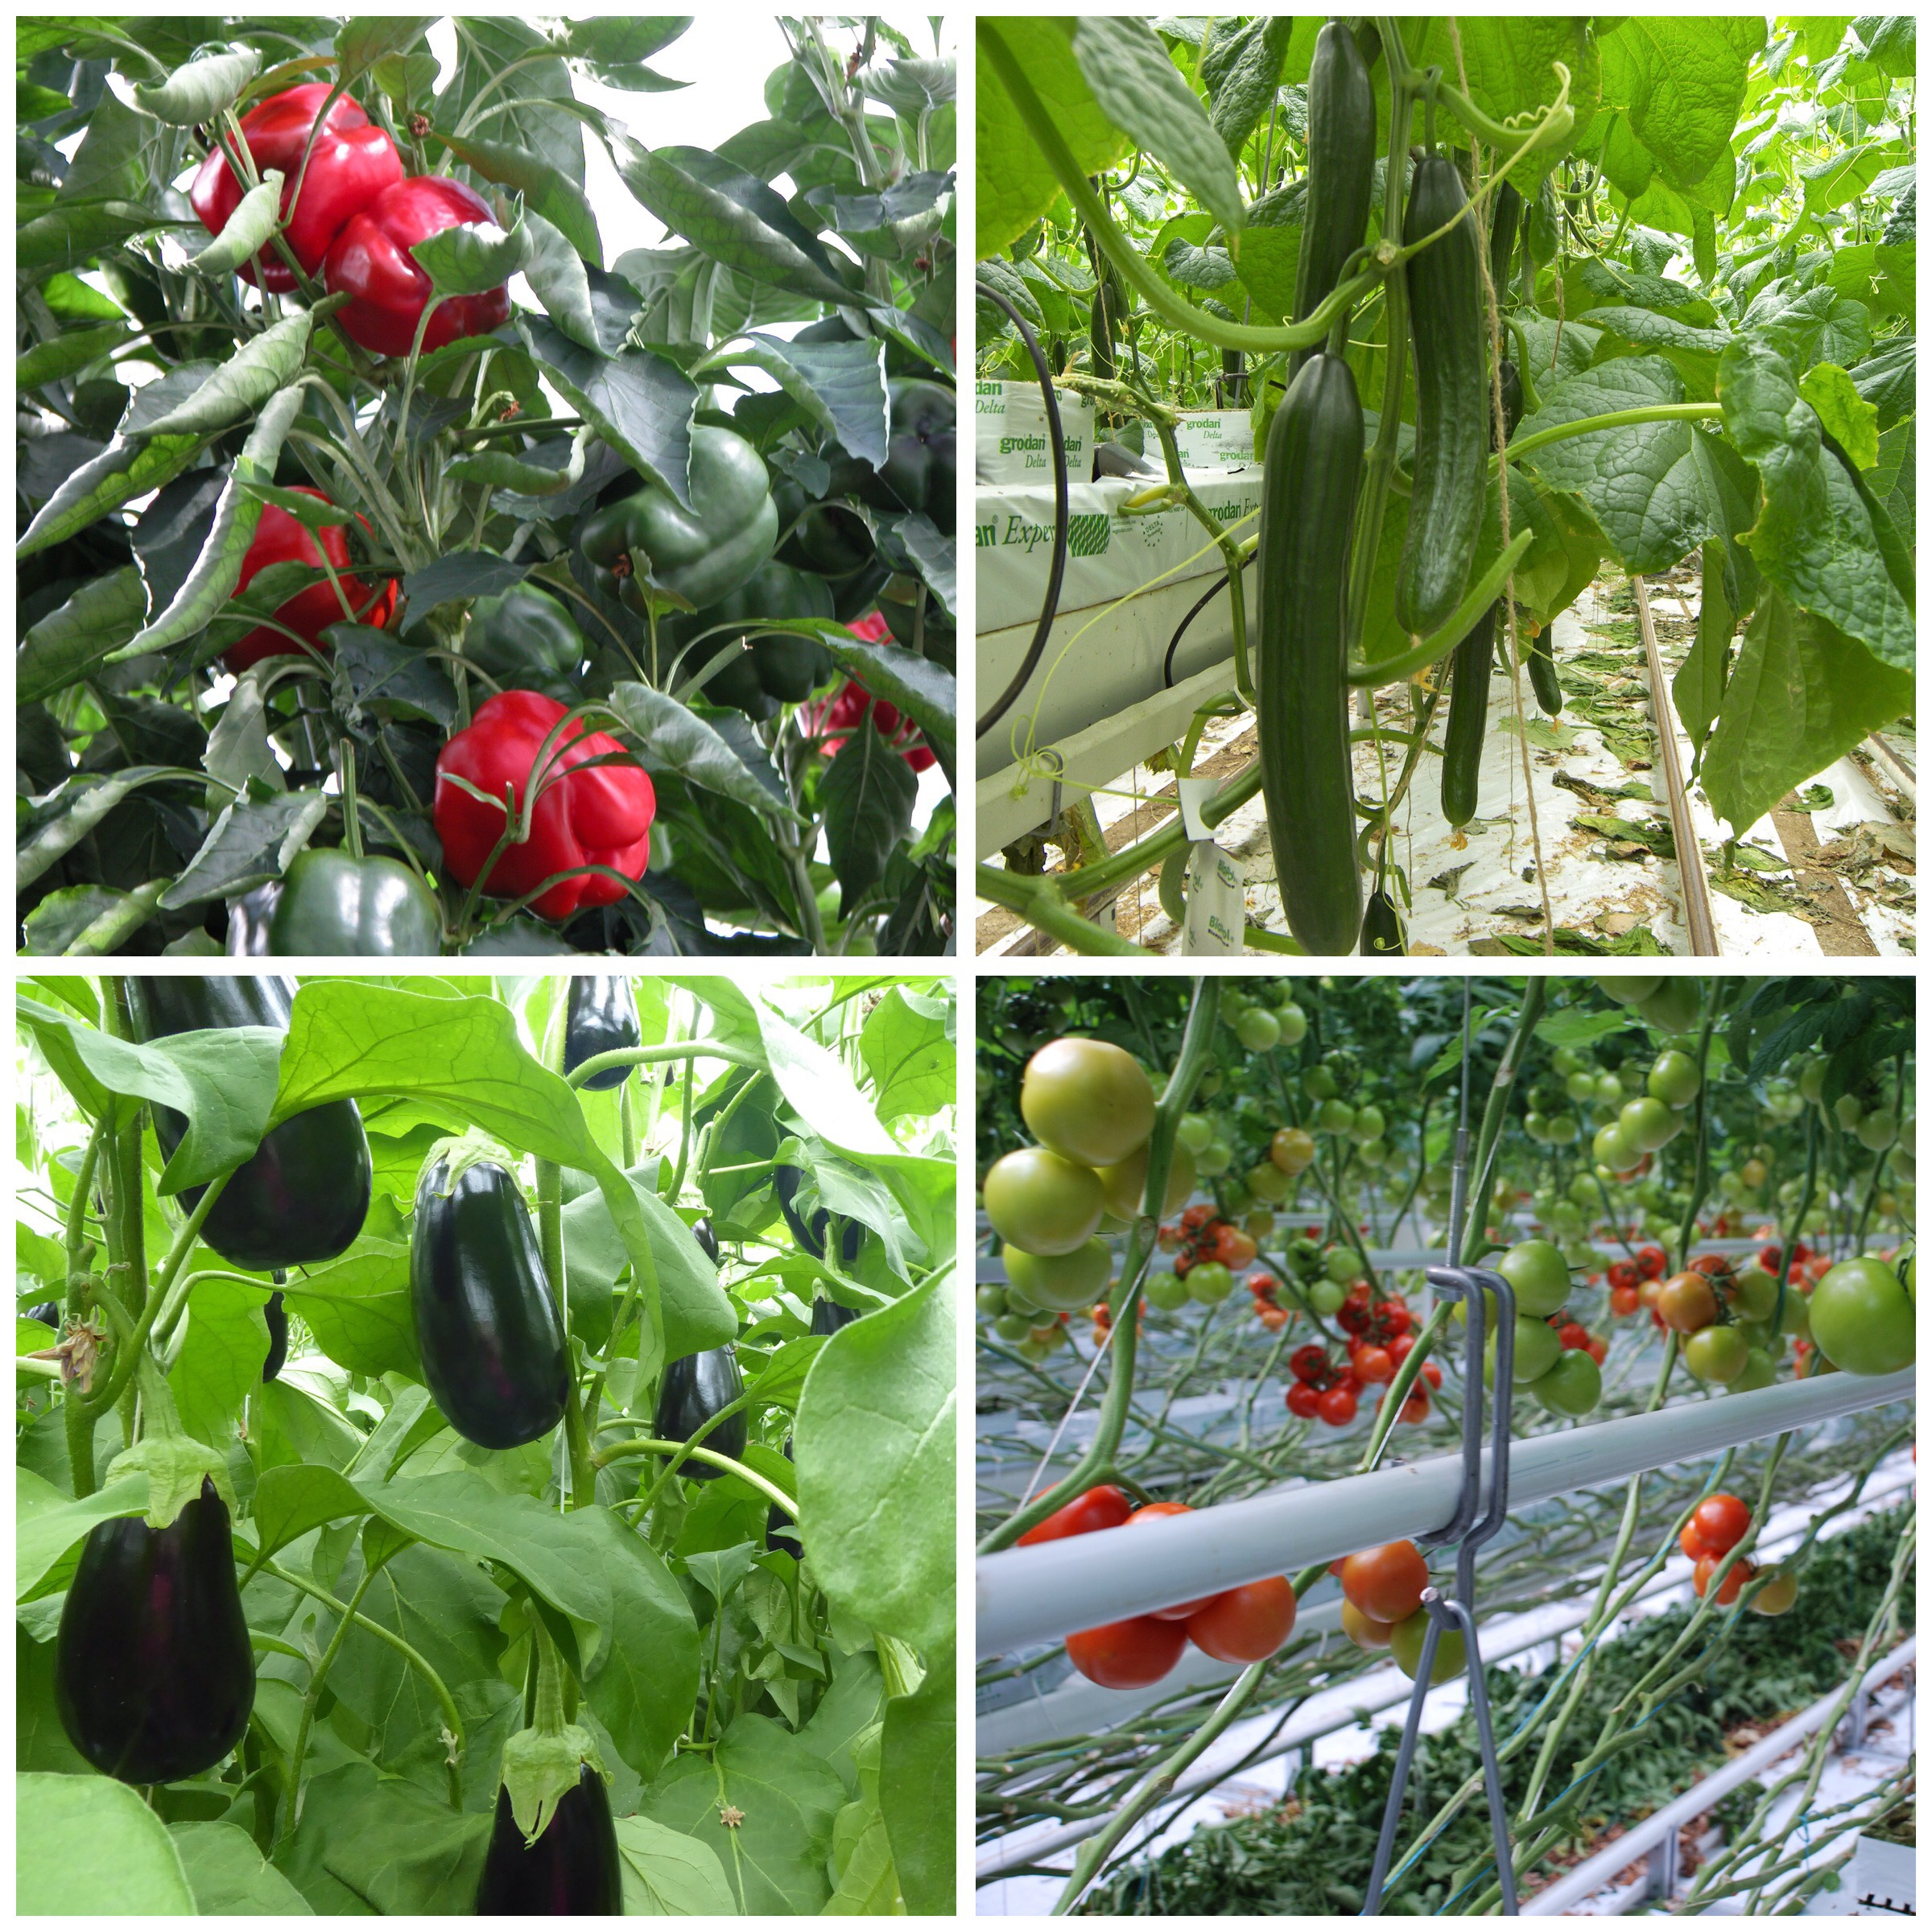

Participants arrange their own trip to the Netherlands and back to New Zealand. You will meet the tour guide at a hotel near Schiphol and you will be dropped back there. The journey through the Netherlands is likely to take approximately 8 days, probably in June, July or August. The maximum group size is 16 - 18 people. The costs will depend on the final program and the number of participants. It may also be possible to combine this trip with Greentech Amsterdam on 8-10 June:
https://www.greentech.nl/amsterdam/

Interested growers can register without obligation via info@HortiServices.nl, stating name and company name, address, telephone number and e-mail address.

For more information please contact Andrea Disco via info@HortiServices.nl

